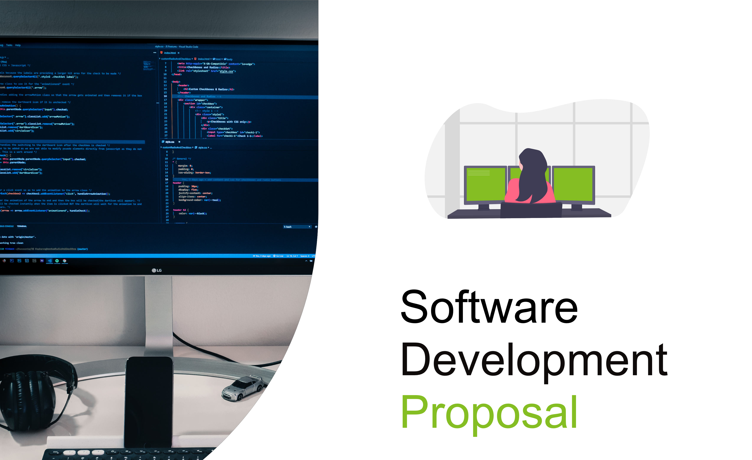

1

# Overview

This proposal outlines the creation of a secure, real time internal dashboard for Daikibo Industrials. The dashboard will show the live operational state of industrial machines that are based across four of Daikibo’s manufacturing sites. Each site includes nine machines transmitting telemetry data to Daikibo’s systems.The solution has the purpose of increasing visibility into factory operations, reducing time to diagnose a problem, and increasing overall equipment efficiency. The dashboard will be hosted within Daikibo’s internal network and will be compatible with the company’s internal authentication system.

# Scope

The scope of this projects entails the creation of comprehensive private dashboard featuring the following capabilities:

* Factory Monitoring: Displays real time health status of all the 9 Daikibo factories.
* Health Labels: Each machine is clearly marked as either Healthy or Unhealthy, making it easy for anyone to understand its current condition at a glance.
* Collapsible View: Expandable factory and machine sections for quick navigation and status history.
* Real Time Updates: Dashboard auto-refreshes with the latest machine data every few seconds.
* Status History: Machines will show recent health history
* Single-Page Overview: Upon logging in, users will be greeted by single-page interface

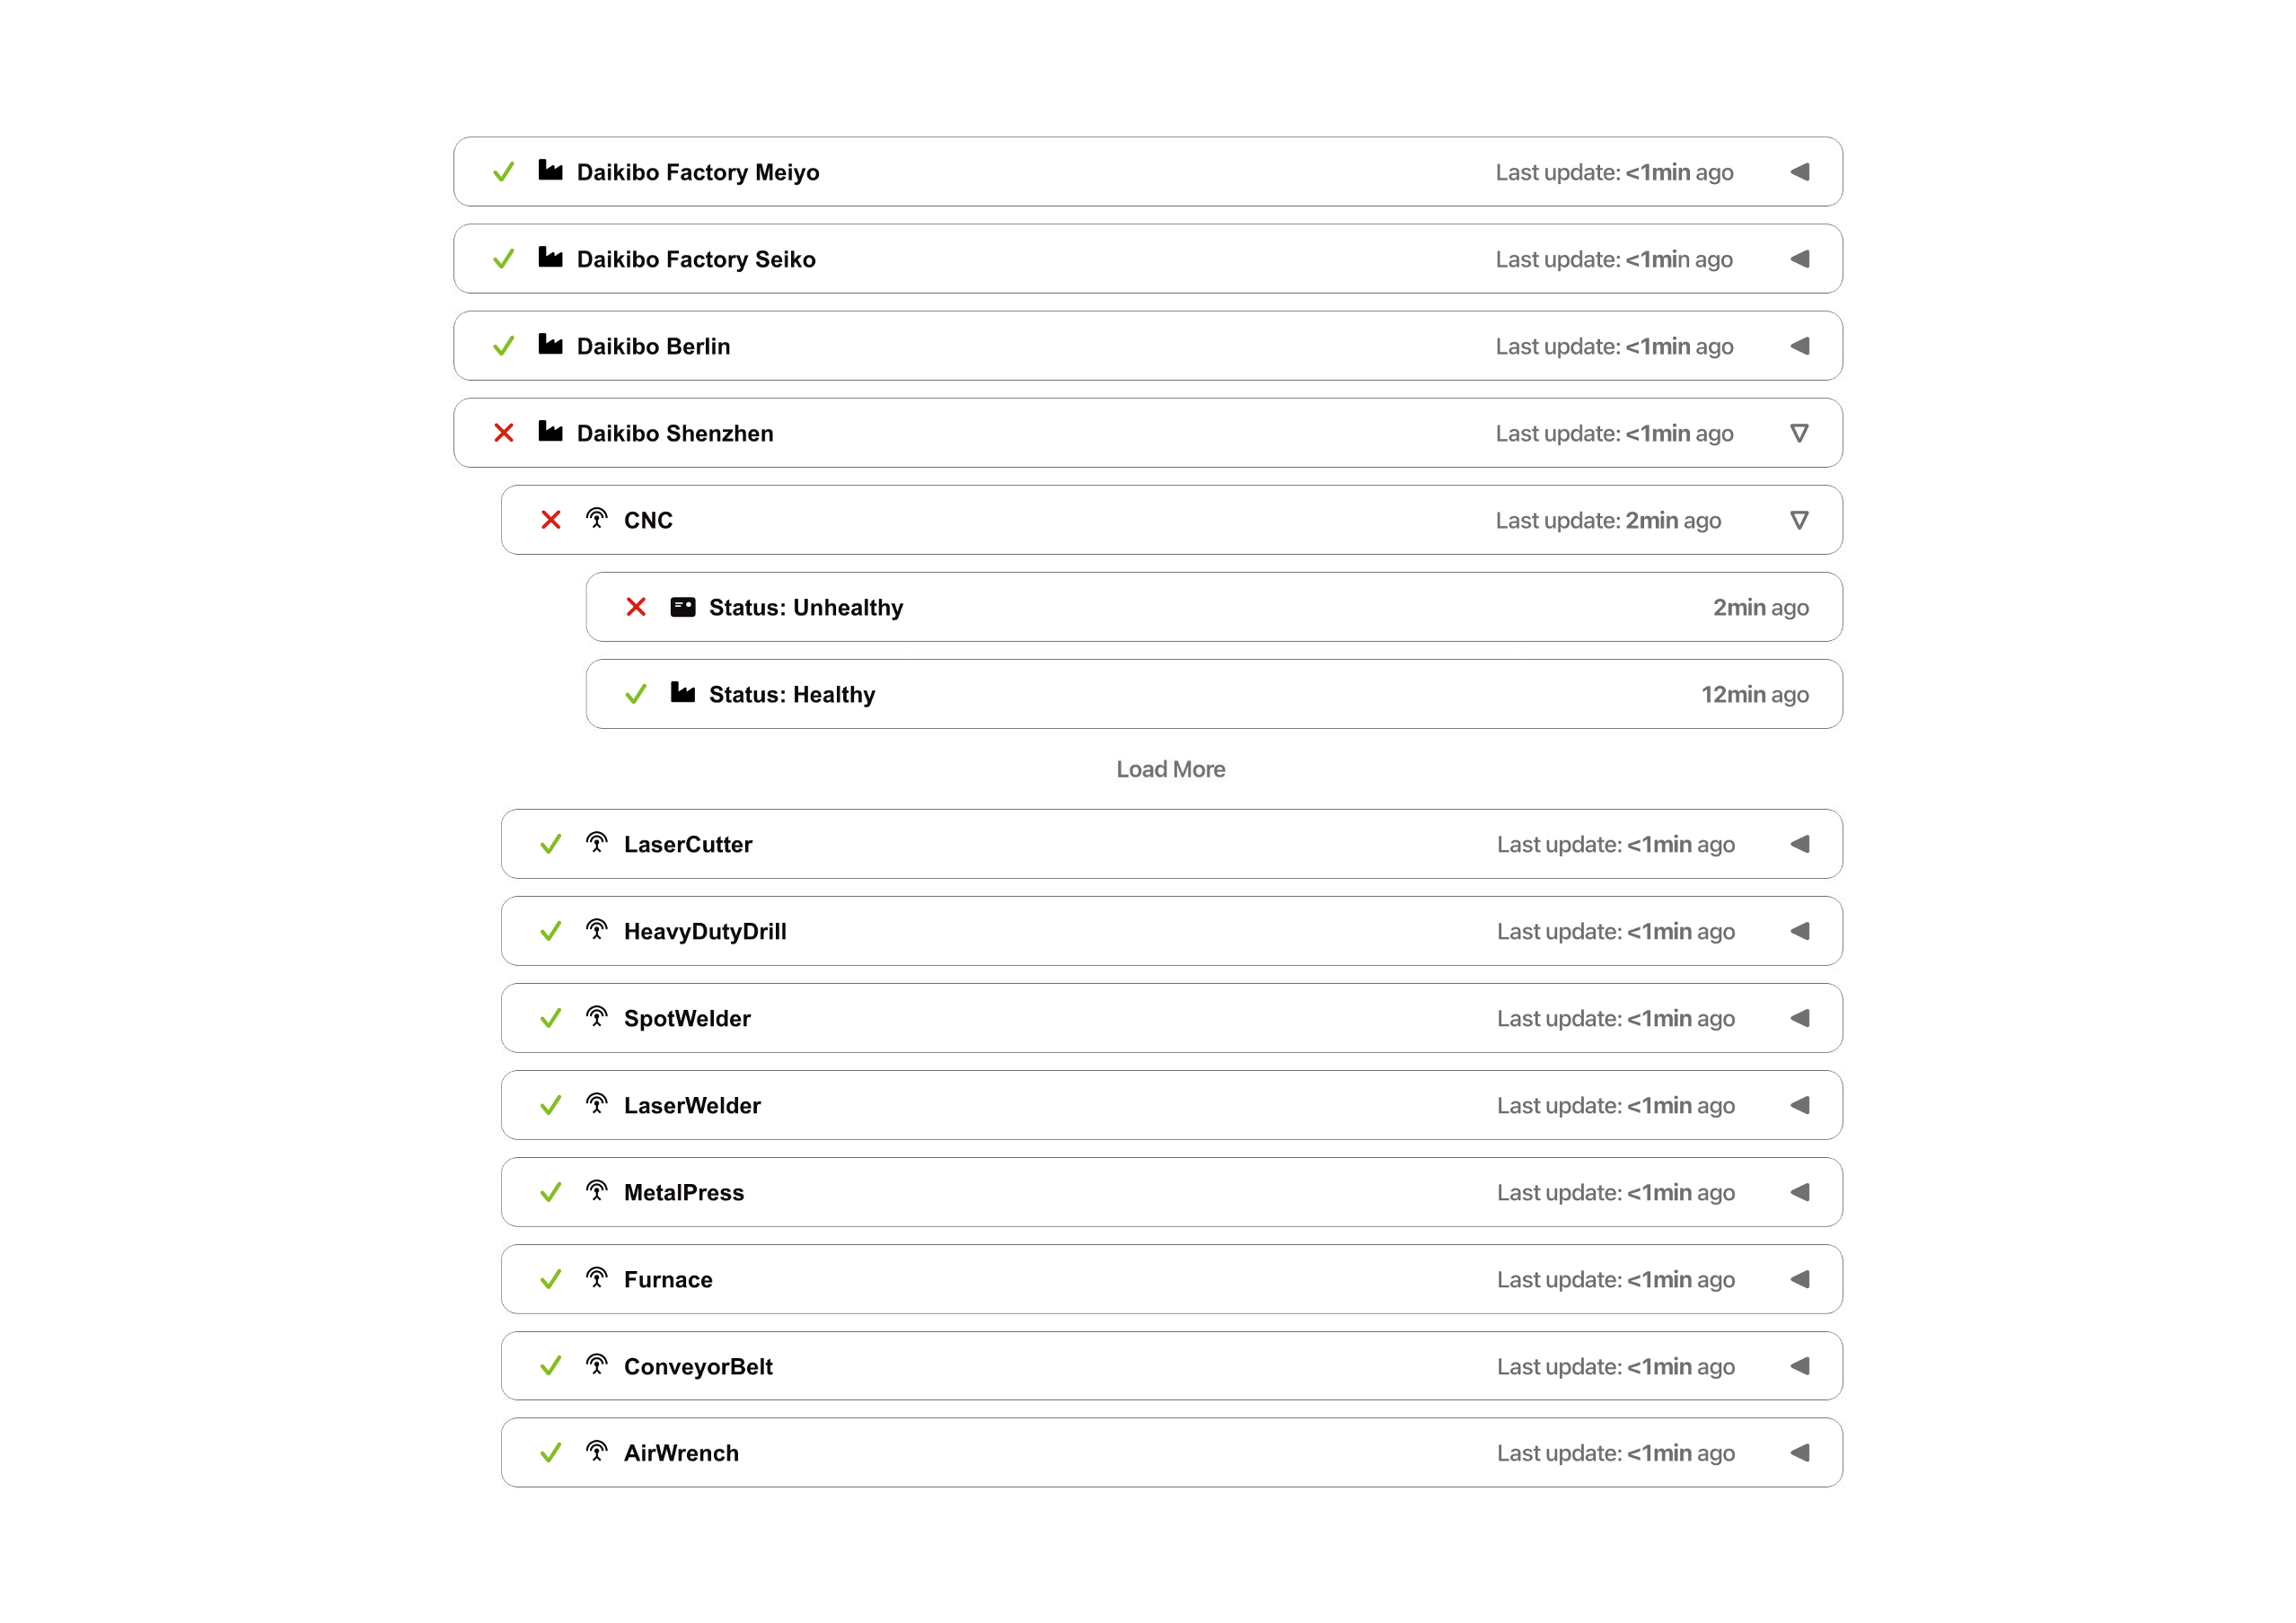

# Estimate

|  |  |
| --- | --- |
| TASKS | HOURS |
| Design | 20 |
| Development | 80 |
| Machine Categories Integration | 20 |
| Machine Tracking Implementation | 50 |
| Health Monitoring | 30 |
| Testing | 50 |
| **Total** | 250 |

1. Timeline
2. [1st of July 2025] Design starts
3. [5st of July 2025] Design complete
4. [7th of July 2025] Development begins
5. [18th of July 2025] Machine tracking and categories integrated
6. [21st of July 2025] Health monitoring module development starts
7. [1st of August 2025] Frontend and real-time updates finalized
8. [4th of August 2025] Testing and QA begins
9. [11th of August 2025] Final review and deployment preparations

# Support

Following the successful deployment of the dashboard, our unwavering to continuous product support will come to play:

* **Bug** **Fixes**: If there are any glitches, lag, or unexpected issues, they will be resolved quickly. The dashboard will be maintained to ensure smooth and reliable performance.
* **Technical** **Support**: Providing assistance through via email or support ticket system during business working hours
* **Performance** **Monitoring**: Ensuring the dashboard remains responsive and reliable
* **Enhancements**: Optional feature upgrades or scalability improvements based on future needs